**Core PHP**

1. Write a PHP program to enter marks of five subjects Physics, Chemistry, Biology, Mathematics and Computer, calculate percentage and grade by if else write a PHP program for find „Thursday‟ in week using switch Function.

Ans:

Code:

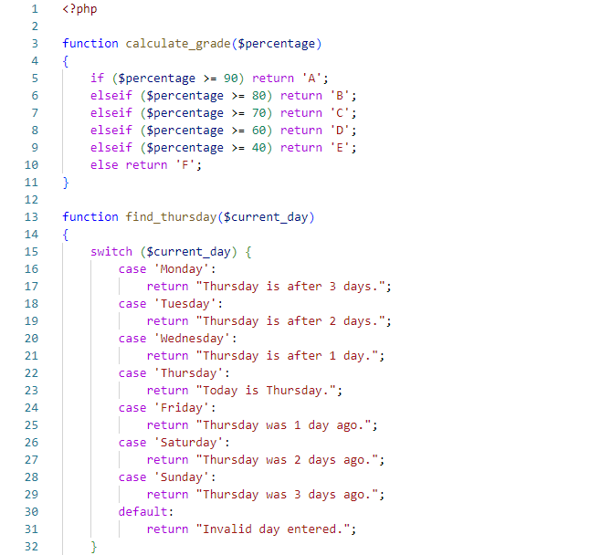

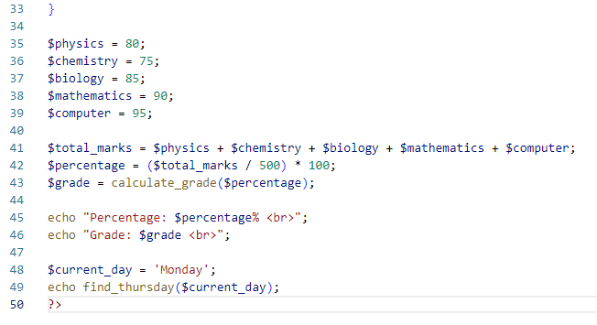

Output:

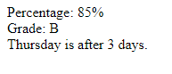

1. Write a PHP program to check Leap years between 1901 to 2016 Using nested if.

Ans:

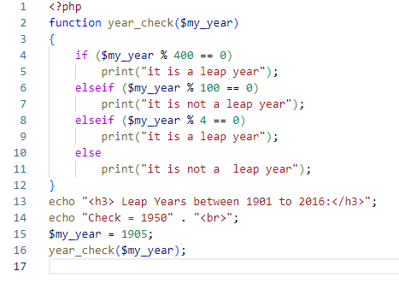

Output:

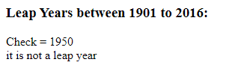

1. Write a PHP program to find the largest of three numbers using ternary Operator.

Ans:

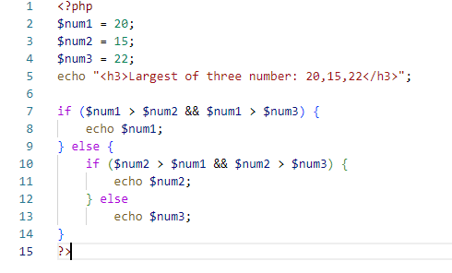

Output:

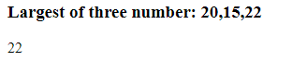

d), Write a program in PHP to print Fibonacci series. 0, 1, 1, 2, 3, 5, 8, 13, 21, o 34

Ans:

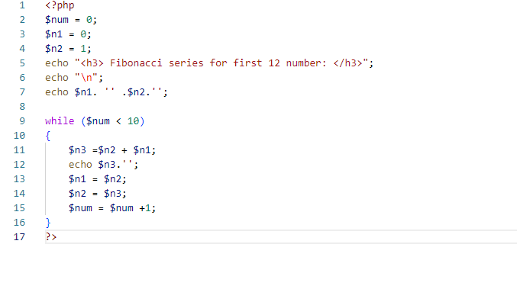

Output:

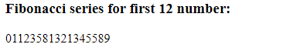

e) Write a program to find whether a number is Armstrong or not Write a program to print the below format:

5 9

2610

3711

4812.

Ans:

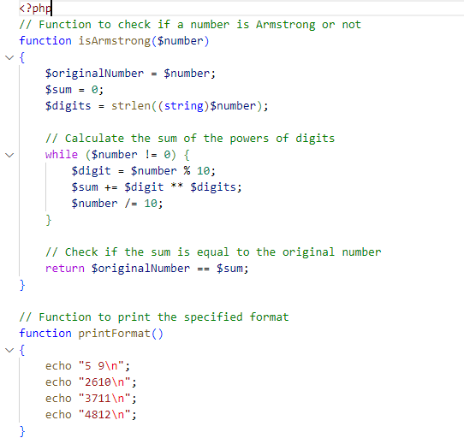

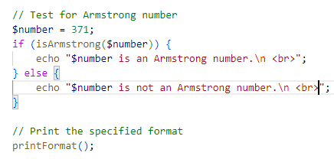

Output:

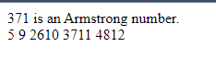

f) Write a program for this Pattern:

*****

*

*

*

*****.

Ans:

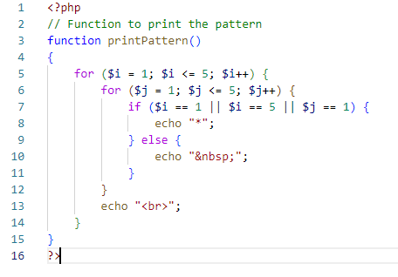

Output:

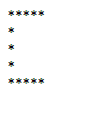

g) What will be the values of $a and $b after the code below is executed? Explain your answer.

$a = '1';

$b = &$a;

$b = "2$b";

Ans:

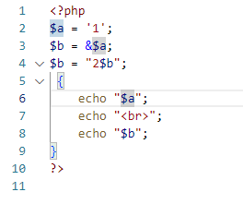

Output:

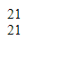

h) How can you tell if a number is even or odd without using any Condition or loop?

Ans:

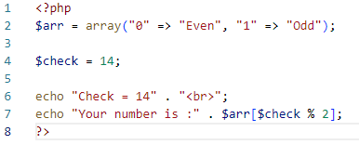

Output:



1. How can you declare the array (all type) in PHP? Explain with example Covert a JSON string to array.

Ans:

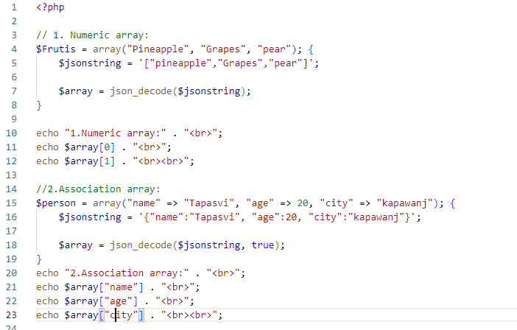

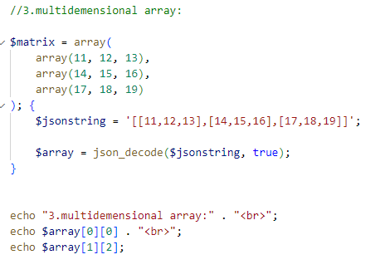

Output

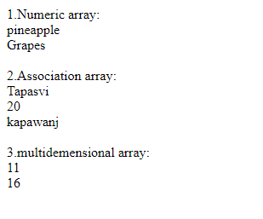

j) Write program to remove duplicate values from array

Ans:

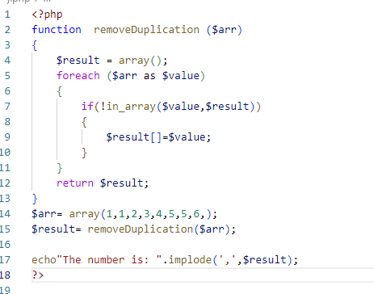

Output:



k) Get random values from array

Ans:

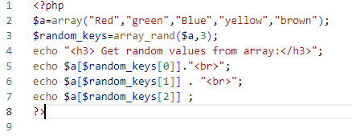

Output:

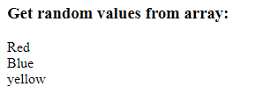

l) Write a PHP script which decodes the following JSON string.

Ans:

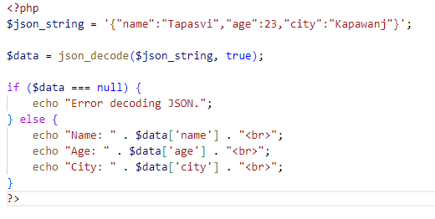

Output:

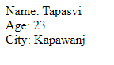

m) Use a for loop to total the contents of an integer array called numbers which has five elements. Store the result in an integer called total.

Ans:

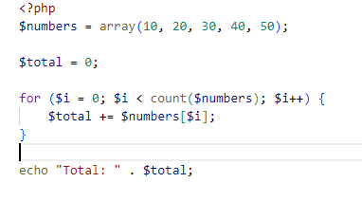

Output:



n) Declare a Multi Dimensioned array of floats called balances having Three rows and five columns.

Ans:

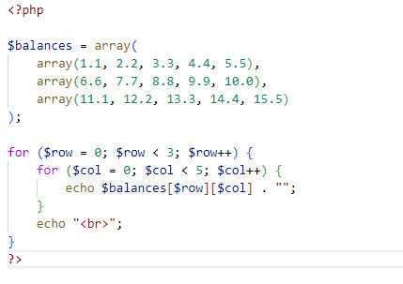

Output:

